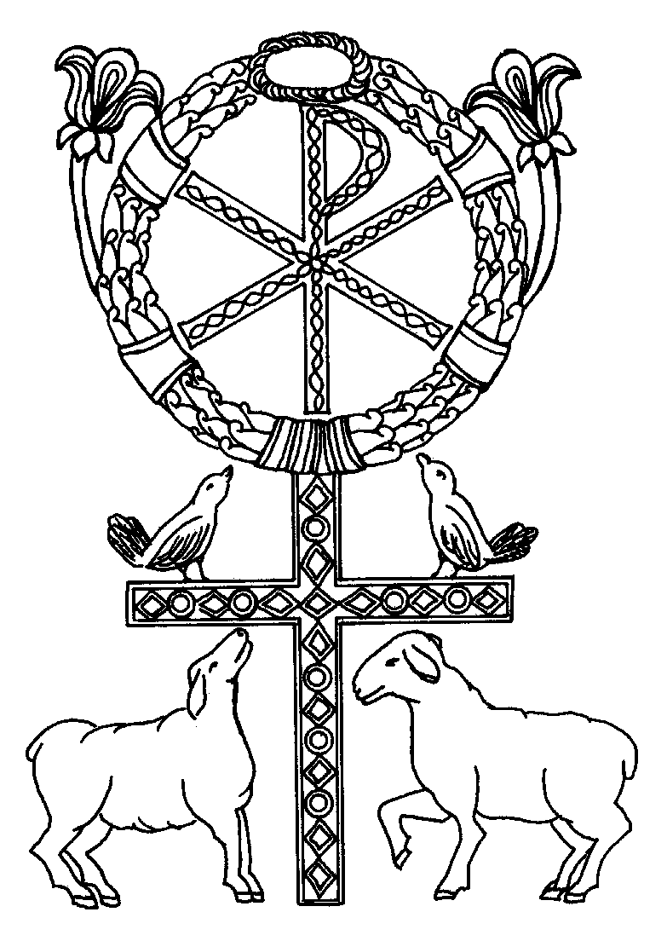
^{Wedding Customary}

Palmer Memorial Episcopal Church
6221 Main Street, Houston, TX 77030/palmerchurch.org

Introduction
Whether your wedding is large or small, it requires preparation and attention to detail. This wedding customary will answer most of your questions about having your wedding at Palmer Memorial Episcopal Church..
We require two months’ notice before the proposed wedding date. The couple also is required to participate in premarital counseling with the clergy regarding “the nature, meaning, and purpose of Holy Matrimony.” The clergy can answer some questions about the wedding ceremony itself, but the counseling sessions primarily discuss marriage. Normally, this takes three or more sessions.
If either person has been divorced, the bishop’s approval is required for the officiating clergy to perform the marriage ceremony. This requires consultation with the clergy, and an additional 30 days may be necessary for the bishop to consider the request.
Because the church vows to support every couple in their married life together, it expects them to participate in the regular life and worship of this—or another—Episcopal parish, and the couple must have a pastoral connection to Palmer Memorial Episcopal Church. We believe that all marriages have the most meaning within the context of a faith community.
A Palmer Church priest officiates at all weddings. Other members of the clergy, either of the Episcopal Church or of other denominations, may be invited by our Rector to assist in the ceremony.
Weddings are not scheduled during the seasons of Advent or Lent, or on Sundays.
Weddings at Palmer Church are celebrated according to the rites in the Book of Common Prayer and other rites approved for use in The Episcopal Church. The Celebration and Blessing of a Marriage is a classic of Christian liturgy, expressing the joy, solemnity, and meaning of this state of life. Although personally composed vows are not permitted, options for readings and prayers enable you to express the uniqueness of your relationship within our tradition.
The main church (nave) seats 350 people.

Flowers and Decorations
Palmer is a beautiful church; we recommend simplicity when decorating it.

1. Speak to the wedding coordinator before selecting your florist. Decorations, including the altar flowers, must be completed by a time agreed upon by the wedding coordinator and the florist.
2. In the nave, no flowers are allowed on the altar itself. Flowers must be delivered in containers that are ready to be placed on the reredos on each side of the cross. The church has no flower containers available for weddings. For the flowers to fit on the reredos, they MUST sit on a base no larger than 7 inches. Each arrangement’s height may not exceed 48 inches.
Once placed on the reredos, flowers may not be removed; they will be used in worship the next Sunday. The florist may retrieve its containers the next Tuesday; check with the church’s front office.
Greenery is allowed in the nave—on the handrails leading to the chancel area, on the chancel rail and on the pews. Arrangements also may be placed on the marble ledges at the base of the stairs: a maximum of 48 inches tall, including the container.
3. In St. Bede’s Chapel, flower arrangements may be placed on two pedestals, provided by Palmer Church.
4. No artificial flowers or greenery (i.e. plastic or silk) are permitted in either the nave or St. Bede’s Chapel. Aisle runners also are not allowed.
5. Our service does not allow for the use of a unity candle.
6. Pew markers, made of ribbons or greenery, are allowed in the nave and chapel. Attach them so they do not damage pews or chairs.
7. Aisle candles are allowed in the nave. They must be furnished and installed by the florist, who also must arrange to light them; this is not the acolyte’s duty.
8. Floral wreaths may be hung on the front doors of the nave. Permanent hooks on the doors make this easy. Remove the wreaths immediately after the ceremony.
9. The florist must be on hand, immediately after the wedding, to remove all decorations—except for the altar flowers, as previously mentioned.

Wedding Music
Weddings at Palmer are accompanied by music that reflects our worship style and musical traditions. Remaining within those traditions, the organist will assist you in choosing wedding music that reflects the occasion’s unique quality. Whether your wedding is informal or stately, the music should suit a religious ceremony. No secular music is appropriate or allowed.
Our organist consults and performs at all Palmer weddings. If desired, additional professional musicians (instrumentalists, singers, choirs) may be hired. The Palmer Director of Music will select all musicians who perform at Palmer weddings.
Policy guidelines are derived from statements on page 14 in the Book of Common Prayer.

Nuptial Eucharist
Many people are returning to the custom of having a Nuptial Eucharist, in which the marriage ceremony includes a celebration of Holy Communion. Generally, this increases the service length by approximately 15 to 20 minutes. As with every celebration of the Holy Eucharist at Palmer Church, all baptized Christians are invited to participate.
Confer with the clergy during your marriage consultation and decide if you wish to include the Eucharist at least a week prior to your wedding.

Rehearsal
Wedding rehearsals usually are directed by the officiating priest and the wedding coordinator. Rehearsals normally require about an hour, and the entire wedding party should attend.

Photography and Video Recordings
1. A flash photo upon entrance to the nave, coming down the aisle, and one of the couple leaving the nave are permitted, but no flash pictures are allowed during the ceremony. Time exposures may be taken from the balcony; do not take them during prayers.
2. It is imperative for the photographer to consult the wedding coordinator before the ceremony. Photographs may be taken of the couple and their attendants in the Family Room, and the area outside it, before the ceremony. A limited number of photographs may be taken of the wedding party after the ceremony. Please limit this photo session to 15 minutes and include only the wedding party and the immediate family. Candles are extinguished at the conclusion of the ceremony.
3. Video recordings are allowed, but the videographer must meet with the wedding coordinator beforehand to discuss where taping is permitted.

Clergy Honorarium
It is customary for the couple to offer the officiating clergy an honorarium for his/her services. For further information, please see “Pricing Information”, page 8.

Fees
Fees are set according to church policy. See “Pricing Information” for details on wedding service fees. If you have questions or concerns, please do not hesitate to discuss them with the clergy.

Marriage License
Arrange for the marriage license with the County Clerk well before the ceremony. Law requires that a marriage license may not be executed within 72 hours of its issuance. Give the license to the wedding coordinator at the rehearsal. The clergyperson is responsible for completing it and returning it to the county.

Dressing Areas
If you wish, the couple and their attendants may dress at the church. Please discuss this with the wedding coordinator. Palmer’s Family Room is designed for this purpose, and the coordinator often can arrange for a second large dressing/waiting area.

Receptions
The parish hall and the patio may be reserved for receptions; a deposit is required to secure the date. Please consult the fee page for rates. On Saturday evenings, the parish hall and the patio are available for two hours after the ceremony and no later than 10 p.m. This time limit is necessary for us to prepare the building for Sunday programs.

The parish-hall reservation includes the room, set-up of tables and chairs, as well as the placement of white tablecloths. It does not include use of the Palmer kitchen; however, you may reserve and use the kitchen for an additional fee. The fee includes full use of the kitchen, glassware, serving dishes and utensils, as well as extra custodial support for clean-up. You also may hire the church sextons (custodians) to assist with your reception (SPECIFY WHAT THEY CAN DO, such as “cooking, serving, removing dishes”). If you wish to play recorded music, a slide show or other audio or audiovisual program, you may reserve set-up services from Palmer’s audiovisual technician. (Please note that the technician does not remain on site for the entire reception.)

For more specific information, please contact Palmer’s lead wedding coordinator:
Ragna Case revised x/xx/xx
713.818-9772
ragna.case@gmail.com

Title I
Canon 18
The Member of the Clergy shall have required that the parties sign the following declaration:

“We understand the teaching of the church that God's purpose for our marriage is for our mutual joy, for the help and comfort we will give to each other in prosperity and adversity, and, when it is God's will, for the gift and heritage of children and their nurture in the knowledge and love of God. We also understand that our marriage is to be unconditional, mutual, exclusive, faithful, and lifelong; and we engage to make the utmost effort to accept these gifts and fulfill these duties, with the help of God and the support of our community.

Signature of one Member of the Couple Signature of one Member of the Couple

Date: Date:

Title I
Canon 19

When marital unity is imperiled by dissension, it shall be the duty, if possible, of either or both parties, before taking legal action, to lay the matter before a Member of the Clergy; it shall be the duty of such Member of the Clergy to act first to protect and promote the physical and emotional safety of those involved and only then, if it be possible, to labor that the parties may be reconciled.

Signature of one Member of the Couple Signature of one Member of the Couple

Date: Date:

Wedding Disclaimer

We have read the wedding customary for Palmer Memorial Episcopal Church and agree to adhere strictly to its regulations as we prepare to celebrate our wedding.
At no time may alcohol be consumed on church property before the wedding by the wedding party or their guests.
It is our responsibility to communicate these guidelines to our caterer, florist, and photographer—and to any other persons helping us prepare for our wedding at Palmer Memorial Episcopal Church.
Must be signed by both parties.

Name – printed Name - Printed

Signature Signature

Date

Wedding Information
Since church records will be made from this information, please use full names only, not initials.

Couple Information

Full Name _________________________
Address______________________________
___________________________________
___________________________________
Cell Phone _________________________
Work Phone _________________________
Email ______________________________
Age ______________________________
Date of Birth _________________________
Place of Birth _________________________
Baptized □ yes □ no
If yes, what denomination? ________________
Confirmed? □ yes □ no
If yes, what denomination? ________________
___________________________________
Church Membership (current)
___________________________________
First marriage? □ yes □ no
Divorced? □ yes □ no
Widower? □ yes □ no
*If divorced, see Remarriage Petition

Parent Information

Parent’s Full Name
___________________________________
Parent’s Address
___________________________________
___________________________________
___________________________________
Parent’s Phone ________________________
Parent’s Full Name
___________________________________
Parent’s Address
___________________________________
___________________________________
___________________________________
Parent’s Phone ________________________
Couple Information

Full Name _________________________
Address______________________________
___________________________________
___________________________________
Cell Phone _________________________
Work Phone _________________________
Email ______________________________
Age ______________________________
Date of Birth _________________________
Place of Birth _________________________
Baptized □ yes □ no
If yes, what denomination? ________________
Confirmed? □ yes □ no
If yes, what denomination? ________________
___________________________________
Church Membership (current)
___________________________________
First marriage? □ yes □ no
Divorced? □ yes □ no
Widower? □ yes □ no
*If divorced, see Remarriage Petition

Parent Information

Parent’s Full Name
___________________________________
Parent’s Address
___________________________________
___________________________________
___________________________________
Parent’s Phone ________________________
Parent’s Full Name
___________________________________
Parent’s Address
___________________________________
___________________________________
___________________________________
Parent’s Phone ________________________
Remarriage Petition Information
Since church records will be made from this information, please use full names only; do not use initials.
Return the completed form to: Palmer Memorial Episcopal Church • 6221 Main Street • Houston, Texas 77030

Member of the Couple
Name(s) of former spouse(s):

Date of final divorce decree(s):

_____________________________________
For a second marriage, a waiting period of one year from the date of the final decree normally is required. If a lengthy separation (beyond two years) has occurred, a six-month waiting period may be granted.
NOTE: If clergy has seen a copy of the divorce decree(s), it is not necessary to include a copy of the decree with this petition.
In the event of a third marriage by either party, the parties to the proposed marriage must consult with a licensed marriage therapist as to their readiness for marriage. The therapist’s written opinion must be conveyed to the petitioning priest and included with the petition to the Bishop.
Insofar as fourth marriages by either party are concerned, no petitions will be considered—except under very unusual circumstances.
If any of the children of the divorced spouse(s) are minors, state the court-ordered financial arrangements for their support and whether all such payments are current.

Member of the Couple
Name(s) of former spouse(s):

Date of final divorce decree(s):

_____________________________________
For a second marriage, a waiting period of one year from the date of the final decree is normally required. If a lengthy separation (in excess of 2 years) has occurred, a 6-month waiting period may be granted.
NOTE: If clergy has seen a copy of the divorce decree(s), it is not necessary to include a copy of the decree with this petition.
In the event of a third marriage by either party, the parties to the proposed marriage must consult with a licensed marriage therapist as to their readiness for marriage. The written opinion of the therapist must be conveyed to the petitioning priest and included with the petition to the Bishop.
Insofar as fourth marriages by either party are concerned, no petitions will be considered except under very unusual circumstances.
If any of the children of the divorced spouse(s) are minors, state the court-ordered financial arrangements for their support and whether or not all payments are current.

Pricing Information
Wedding Services
Couple’s Name
Wedding Date

Item Description | Quantity | Price Per
Basic Services for the Nave (1) | 1 | $1,500.00
Basic Services for St. Bede’s Chapel (1) | 1 | $750.00
OPTIONAL SERVICES
Parish Hall Rental for Reception (2) | 1 | $1,500.00
Patio Rental for Reception (2) | 1 | $750.00
Bells | 1 | $150.00
Wedding Leaflets | 1 | $1.00
Security Officer Overtime Fees | 1 | $25/hour
City of Houston Street Parking Permit (3) | 1 | $60
Off-Duty HPD Officer required by COH for Permit (3) | 4 hrs | $40/hour
Custodial Overtime Fees | 1 | $100/each
Kitchen Use (4) | 1 | $1000.00
AV Tech for Reception Set-up (5) | 1 | $50.00
Less Deposit Paid
 |  | Subtotal
 |  | Tax - 0%
Fees due at or before rehearsal. Please remit to wedding coordinator. |  | TOTAL

Item Description | Quantity | Price Per
Suggested Clergy Honorarium  (Please make a separate check payable to the Clergy person officiating wedding and give it directly to the Priest on your wedding day or at rehearsal.) | 1 | $300.00
 |  | TOTAL

(1) Basic Services of the Church Office includes (i) Palmer Clergy and two Wedding Coordinators; (ii) arrangement conference and any follow-up visits; (iii) coordination of service; (iv) clerical assistance with various forms and permits associated with service; (v) organist; (vi) overhead including administration, 2 security guards for a wedding in the Nave and one for a wedding in the Chapel, equipment and facility expenses up to 4 hours of reserved time on campus.
(2) Reception rentals include use of room, tables & chairs with white table cloths. It does not include kitchen use, church dishes, or AV assistance.
(3) Fee is dictated by the City of Houston Office of Mayor Special Events Department as of October 01, 2018.
(4) Kitchen rental includes full use of Palmer's parish hall kitchen, glassware and serving dishes if needed, and extra custodial support for clean-up.
(5) AV Tech will communicate with couple via phone or email prior to wedding to get an understanding of what the needs are and will arrive at parish hall or patio prior to start of reception to make sure all equipment is set and ready to go. Tech will not stay on campus for duration of event but may stay for up to 1 hour, including set up time, to ensure that all is running smoothly.
Note: Soloist fees or fees for extra musicians are to be contracted by the couple and paid separately directly to the musicians. If a member of the Palmer Choir is requested, the fee is $150 paid directly to the soloist.

